

**POSTGRADUATE PROGRAMME IN MANAGEMENT (MARKETING)**

**Academic Year 2024-25**

**COURSE NAME**: **Market Research and Method (Session 10)  
Quarter: 3**

**Submitted to:**

Professor Vishnu Sir

Github Link: [**https://github.com/sashutosh24/MarketResearchSession10**](https://github.com/sashutosh24/MarketResearchSession10)  
**by:**

**GROUP 9**

Ashutosh Singh (0055)

Natasha Shah (0110)

Anushka Shetty

# • Marketing Mix Model: Ad Stock & Saturation Effect

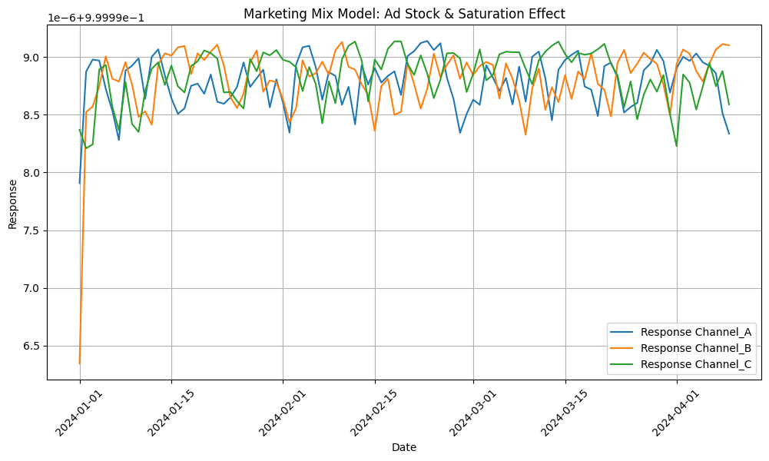

**Key Insights:**

1. **Channel Trends**:
   * **Channel A**: Consistent high performance with minor dips, indicating strong audience engagement.
   * **Channel B**: Slow initial growth but stabilizes, suggesting delayed ad effectiveness or optimizations.
   * **Channel C**: Strong performance but fluctuates more, indicating sensitivity to external factors.
2. **Ad Saturation**:
   * Responses stabilize after mid-January, showing diminishing returns due to saturation.
3. **Recommendations**:
   * Focus on optimizing **Channel B's** early performance.
   * Investigate **Channel C's** fluctuations for external influences.
   * Shift strategies to target engagement over increased ad spend in the saturated phase.

# • Ad Stock Effect with Different Decay Factors

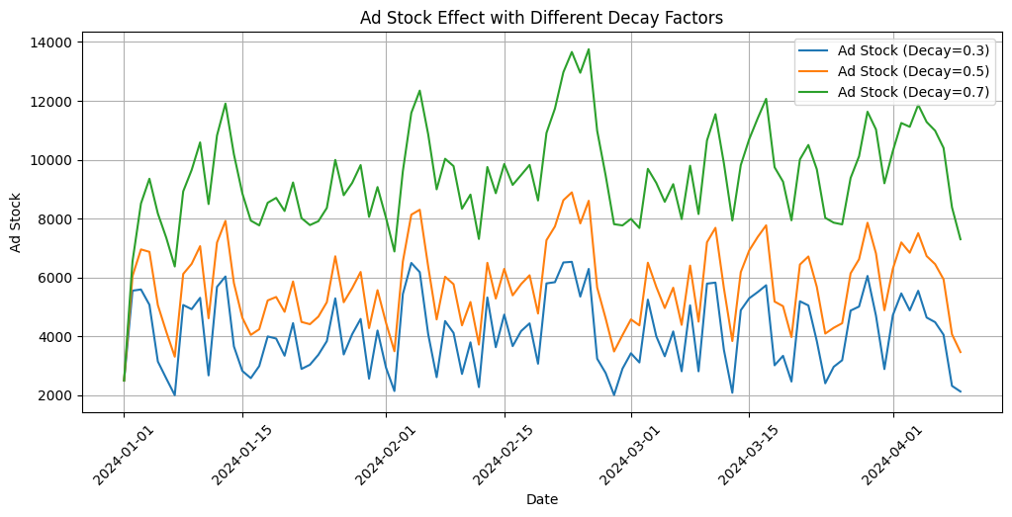

**Insights from the Graph: Ad Stock Effect with Different Decay Factors**

1. **Ad Stock Trends**:
   * **Decay = 0.3 (Blue)**: The fastest decay factor shows the lowest ad stock levels, indicating that ad effectiveness diminishes quickly.
   * **Decay = 0.5 (Orange)**: A moderate decay rate leads to slightly higher ad stock retention compared to decay = 0.3.
   * **Decay = 0.7 (Green)**: The slowest decay rate maintains the highest ad stock levels, showing a prolonged effect of advertising.
2. **Variations Over Time**:
   * Ad stock fluctuates throughout the period, with higher peaks for decay = 0.7 due to longer-lasting ad impact.
   * Lower decay factors (0.3 and 0.5) result in sharper declines after peak moments, showing faster diminishing returns.
3. **Implications**:
   * **Higher Decay (0.3)**: Suitable for short-term campaigns where immediate impact is required but not sustained.
   * **Lower Decay (0.7)**: Works well for long-term campaigns with extended ad effects and retention.
4. **Recommendations**:
   * Choose decay = 0.3 or 0.5 for time-sensitive campaigns or when frequent ad refreshes are feasible.
   * Opt for decay = 0.7 for brand-building campaigns focused on sustained awareness over time.
5. • **Saturation Effect with Different Parameters**

# • Saturation Effect with Different Parameters

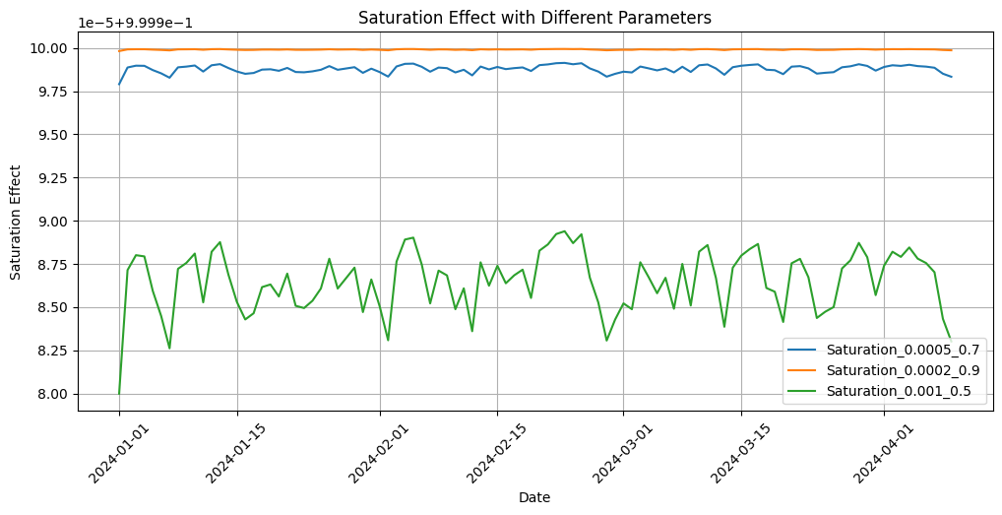

**Insights from the Graph: Saturation Effect with Different Parameters**

1. **Saturation Trends**:
   * **Saturation (0.0005, 0.7) - Blue Line**:
     + Shows a slight downward trend over time, indicating a steady decline in the effectiveness of ads as saturation increases.
   * **Saturation (0.0002, 0.9) - Orange Line**:
     + Maintains a nearly flat curve, implying minimal saturation effect and sustained ad performance over time.
   * **Saturation (0.001, 0.5) - Green Line**:
     + Demonstrates sharp fluctuations, indicating that this parameter combination leads to more volatile ad performance and higher sensitivity to saturation.
2. **Parameter Effect**:
   * **Higher Parameter Values (e.g., 0.0005 or 0.001)**:
     + Lead to more pronounced saturation effects, with quicker diminishing returns.
   * **Lower Parameter Values (e.g., 0.0002)**:
     + Result in slower saturation, indicating better ad efficiency and prolonged impact.
3. **Implications**:
   * **Blue Line (Moderate Saturation)**: Balanced for long-term campaigns, with gradual diminishing returns.
   * **Orange Line (Low Saturation)**: Ideal for consistent and sustainable ad effectiveness over time.
   * **Green Line (High Saturation)**: Suitable for short bursts of ads but not sustainable due to rapid saturation.
4. **Recommendations**:
   * Use **lower saturation parameters (e.g., 0.0002, 0.9)** for campaigns focusing on sustained engagement.
   * For short-term campaigns, higher parameters like **0.001, 0.5** might be acceptable for immediate high-impact but require frequent adjustments to avoid fatigue.
   * Monitor saturation levels closely to optimize ad spend and maximize ROI.

# • Feature Importances (Bar Chart)

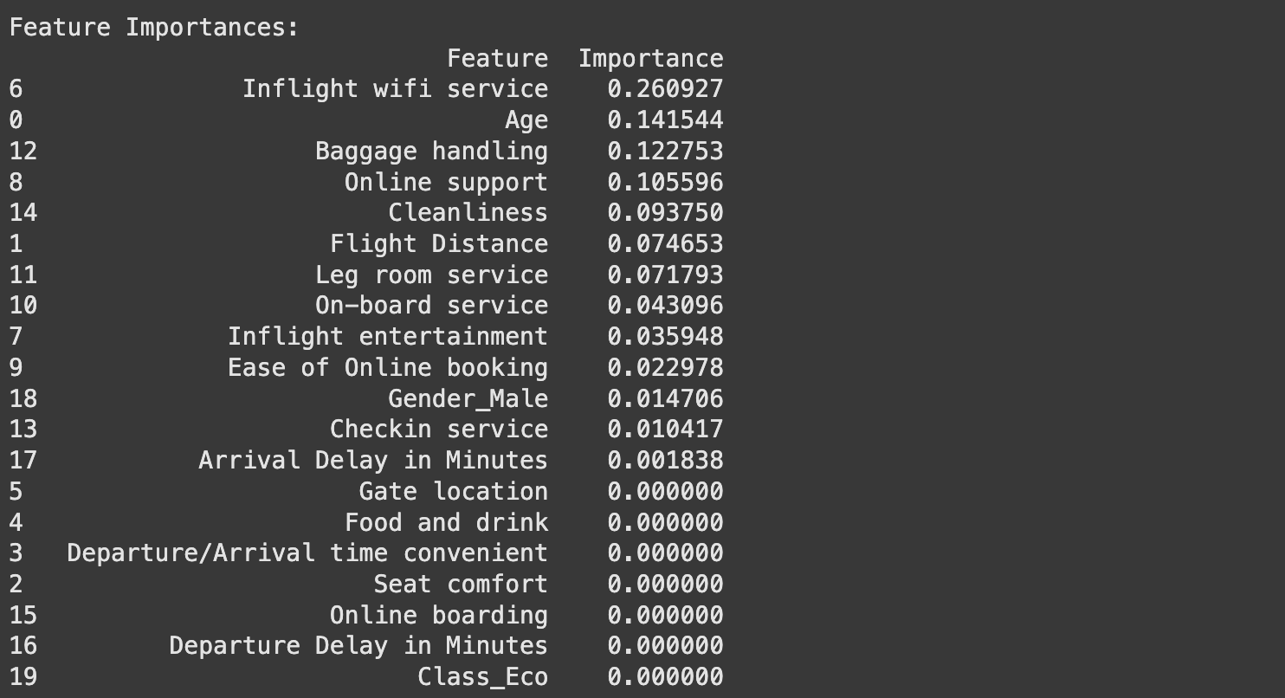

**Insights from Feature Importance Chart:**

1. **Key Features Driving Importance**:
   * **Inflight Wi-Fi Service (0.2609)**: The most important factor, indicating that passenger satisfaction heavily relies on the availability and quality of in-flight Wi-Fi.
   * **Age (0.1415)**: Significant, possibly reflecting preferences or satisfaction differences across age groups.
   * **Baggage Handling (0.1227)**: Highlights the importance of efficient baggage handling in passenger satisfaction.
   * **Online Support (0.1056)**: Indicates that customer service availability and responsiveness are critical.
2. **Moderately Important Features**:
   * **Cleanliness (0.0938)**: Clean environments have a noticeable impact on passenger satisfaction.
   * **Flight Distance (0.0747)**: Suggests that longer flights may affect satisfaction differently, depending on service quality.
   * **Leg Room Service (0.0718)**: Comfort during the flight is moderately important to passengers.
3. **Least Important Features**:
   * **Class (Eco), Food and Drink, Departure/Arrival Time Convenience (0.0000)**:
     + These features seem to have no measurable impact on satisfaction in this dataset, potentially due to uniform quality or lower passenger expectations for these factors.
4. **Implications**:
   * Airlines should prioritize **inflight Wi-Fi service, baggage handling, and cleanliness**, as they have the largest impact on satisfaction.
   * Efforts to improve **legroom service and online support** can further enhance customer experience.
   * Lesser focus can be placed on low-impact areas like **seat comfort or food and drink**, unless targeting niche markets.
5. **Recommendations**:
   * Invest in **technology upgrades** for Wi-Fi and online support to enhance passenger satisfaction.
   * Ensure consistent cleanliness standards and optimize **baggage handling** processes to avoid delays or issues.
   * Tailor strategies to address preferences of specific **age demographics**, especially if a significant portion of passengers belong to a certain group.

# • Data Preview

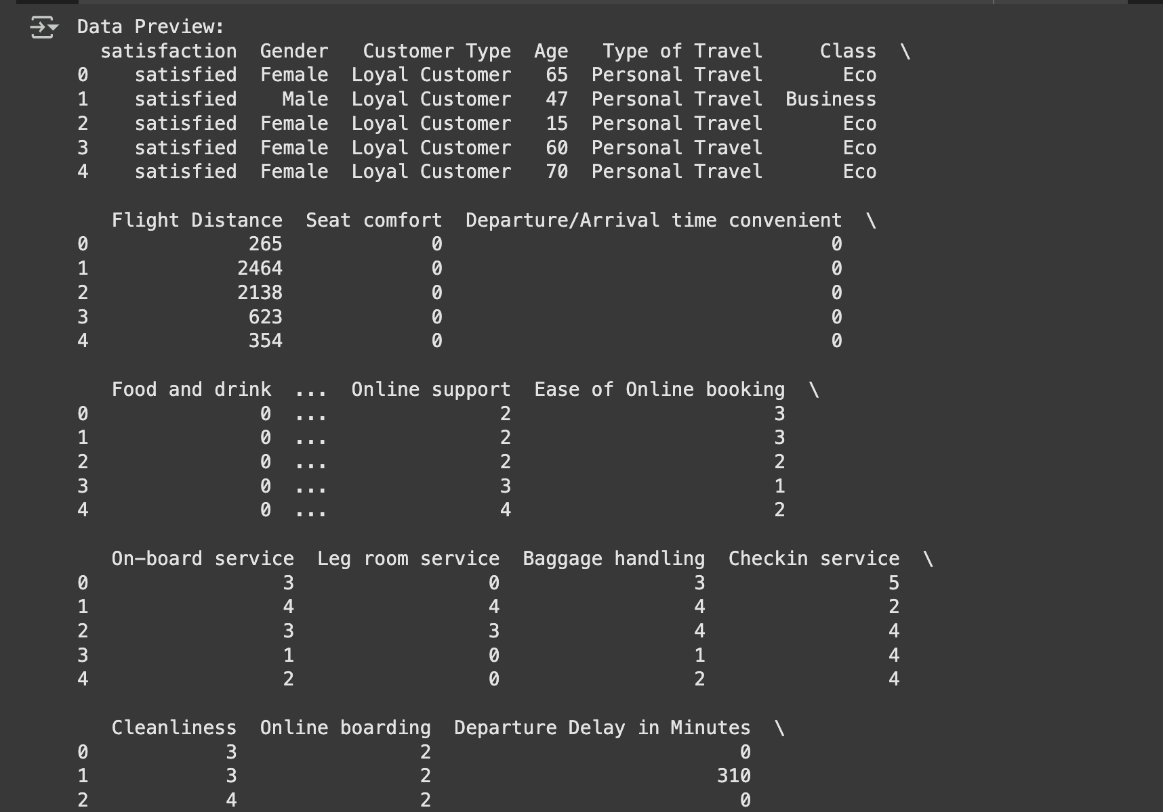

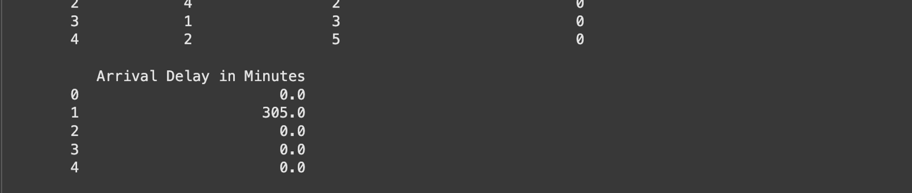

**Insights from Data Preview:**

1. **Customer Satisfaction**:
   * The dataset contains "satisfaction" as the target variable, which classifies customers as "satisfied" or not.
   * This is a **classification problem** where features like gender, age, travel type, and flight service attributes determine satisfaction.
2. **Demographics and Travel Type**:
   * **Gender**: The dataset tracks satisfaction for both male and female passengers.
   * **Age**: Varies widely (e.g., 15–70 years in the preview), indicating satisfaction may differ across age groups.
   * **Type of Travel**: Includes "Personal Travel" and "Business Travel," which likely impact satisfaction levels differently.
3. **Key Features Related to Services**:
   * **Flight Distance**: Ranges from short (265 miles) to long (2464 miles), suggesting varying expectations for long vs. short-haul flights.
   * **Seat Comfort & Leg Room**: Some passengers rate these attributes poorly (0–4), likely impacting satisfaction negatively.
   * **Baggage Handling**: Ratings range from 0–4, showing inconsistencies in service.
4. **Operational Factors**:
   * **Arrival and Departure Delays**:
     + Significant delays observed (e.g., 305 minutes in one case), which can severely impact satisfaction.
   * **Cleanliness and On-board Service**: Rated on a scale of 0–5, indicating variability in service quality.
5. **Online Services**:
   * **Ease of Online Booking** and **Online Support**: These features are moderately rated (mostly 2–4), which may affect convenience and satisfaction.

**Recommendations:**

1. **Improve Core Services**:
   * Focus on **baggage handling, seat comfort, and legroom** as these are key to passenger experience.
   * Reduce delays by optimizing operations, as significant delays severely impact satisfaction.
2. **Enhance Online Experience**:
   * Improve **online support and booking platforms** to cater to tech-savvy passengers, especially for younger travelers.
3. **Targeted Strategies**:
   * For long-haul flights, prioritize cleanliness, comfort, and inflight services.
   * For business travelers, focus on convenience, punctuality, and inflight Wi-Fi.
4. **Data Insights**:
   * Further analyze correlations between travel type, demographic factors, and service ratings to identify satisfaction drivers for different customer segments.

# • Logistic Regression Coefficients

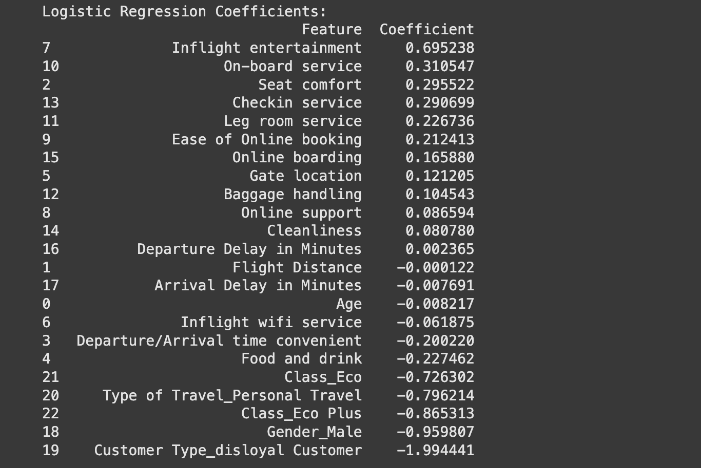

**Insights from Logistic Regression Coefficients:**

1. **Key Positive Factors (High Coefficients)**:
   * **Inflight Entertainment (0.695)**: Most influential positive factor for customer satisfaction. Improving this can significantly boost satisfaction levels.
   * **On-board Service (0.311)** and **Seat Comfort (0.296)**: Highlight the importance of customer experience during the flight.
   * **Check-in Service (0.291)** and **Leg Room Service (0.227)**: Indicate that pre-flight and in-flight comfort contribute to satisfaction.
   * **Ease of Online Booking (0.212)**: Ensures a smooth booking experience positively impacts customer perceptions.
2. **Moderate Positive Factors**:
   * **Online Boarding (0.166)**, **Gate Location (0.121)**, and **Baggage Handling (0.105)**: Secondary factors, but still crucial for an overall positive experience.
   * **Cleanliness (0.081)** and **Online Support (0.087)**: Hygiene and customer service responsiveness moderately influence satisfaction.
3. **Negative Factors (Low/Negative Coefficients)**:
   * **Customer Type (Disloyal Customer: -1.994)**: The strongest negative impact, indicating that disloyal customers are significantly harder to satisfy.
   * **Gender (Male: -0.960)**: Male passengers may have lower satisfaction levels compared to females.
   * **Travel Class (Eco: -0.726, Eco Plus: -0.865)**: Economy and premium economy passengers show lower satisfaction compared to business class.
   * **Type of Travel (Personal Travel: -0.796)**: Personal travelers are less satisfied compared to business travelers.
   * **Food and Drink (-0.227)**: Indicates dissatisfaction with the quality or variety of food services.
4. **Minimal Impact Factors**:
   * **Departure Delay (0.002)** and **Arrival Delay (-0.008)**: These factors have very little influence on satisfaction compared to others.
   * **Flight Distance (-0.0001)**: No significant impact, suggesting distance alone does not influence satisfaction.

**Key Insights:**

1. **Enhance Key Drivers**:
   * Focus on improving **Inflight Entertainment**, **On-board Service**, and **Seat Comfort** to drive higher satisfaction.
   * Address **Check-in Service** and **Leg Room Service** to improve passenger comfort.
2. **Target Underperforming Areas**:
   * Address issues with **Food and Drink** and **Economy Class** to reduce dissatisfaction.
   * Develop strategies to retain **disloyal customers**, as they exhibit the lowest satisfaction.
3. **Demographic Focus**:
   * Male passengers and personal travelers are harder to satisfy; targeted improvements for these groups could improve overall ratings.
4. **Customer Segmentation**:
   * Invest more in **business travelers** and higher-class passengers, as their satisfaction is easier to maintain.

# • SHAP Feature Importance (Bar Plot)

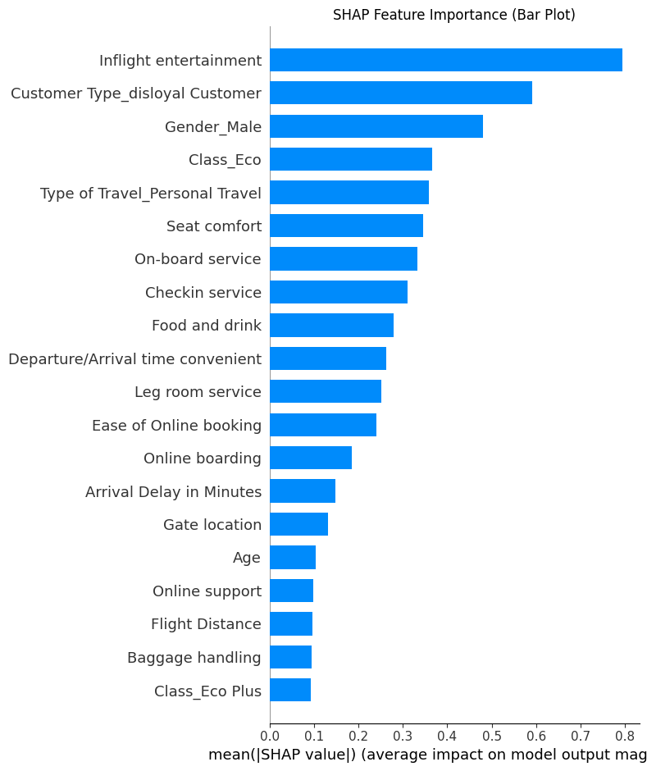

**Insights from SHAP Feature Importance Plot:**

1. **Top Features Driving Customer Satisfaction**:
   * **Inflight Entertainment**: The most critical factor with the highest SHAP value, confirming its strong influence on customer satisfaction. Enhancing this feature will yield significant improvements in satisfaction.
   * **Customer Type (Disloyal Customer)**: A major negative driver, indicating that retaining loyal customers is key to maintaining higher satisfaction levels.
   * **Gender (Male)**: Male passengers tend to have a lower satisfaction rate compared to female passengers, emphasizing the need for tailored strategies to meet their expectations.
2. **Secondary Features**:
   * **Class (Eco)**: Economy passengers exhibit lower satisfaction, likely due to fewer amenities compared to premium classes.
   * **Type of Travel (Personal Travel)**: Personal travelers are less satisfied than business travelers, likely due to differing expectations for travel convenience and comfort.
   * **Seat Comfort and On-board Service**: These remain essential contributors to a positive travel experience and satisfaction.
3. **Moderate Impact Features**:
   * **Check-in Service and Food/Drink**: Moderate influence, indicating opportunities for improvement in these areas to boost customer experience.
   * **Leg Room Service and Ease of Online Booking**: Highlight the importance of both in-flight comfort and pre-flight convenience.
4. **Lesser Impact Features**:
   * **Arrival Delay in Minutes, Gate Location, and Age**: These have a smaller but still relevant effect on satisfaction. Addressing these factors could provide incremental benefits.
   * **Online Support, Flight Distance, and Baggage Handling**: Least impactful in this model, suggesting that these are secondary considerations for passengers.

**Recommendations:**

1. **Focus on Key Drivers**:
   * Invest in **Inflight Entertainment** to maintain a competitive advantage.
   * Prioritize strategies to retain **loyal customers** by enhancing perks and improving their experience.
2. **Target Underperforming Segments**:
   * Address satisfaction gaps for **male passengers**, **economy class**, and **personal travelers** through personalized offers and improved amenities.
3. **Optimize Secondary Features**:
   * Improve **on-board services, seat comfort**, and **food/drink quality** to further enhance overall satisfaction.
   * Streamline pre-flight experiences, especially **check-in and online booking**, to improve convenience.
4. **Monitor Minor Features**:
   * While lesser impactful, ensure **arrival/departure convenience** and **gate location** issues are minimized to avoid unnecessary dissatisfaction.

# • SHAP Summary Dot Plot

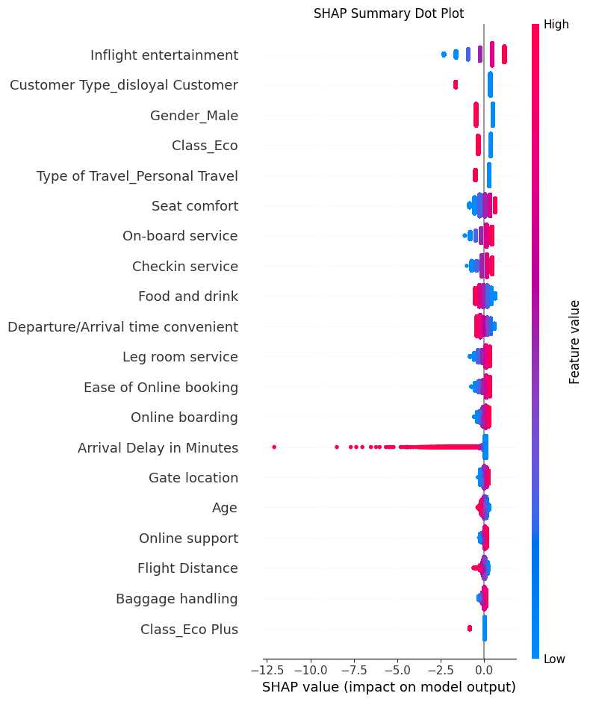

**Insights from SHAP Summary Dot Plot:**

1. **Top Positive and Negative Influences**:
   * **Inflight Entertainment**:
     + High feature values (e.g., better inflight entertainment quality) strongly drive **positive customer satisfaction** (right side).
     + Poor entertainment leads to negative impacts (left side).
   * **Customer Type (Disloyal Customer)**:
     + Disloyal customers contribute significantly to **negative satisfaction**. Retention efforts must focus on this segment.
   * **Gender (Male)** and **Class (Eco)**:
     + Male passengers and those in economy class tend to have **lower satisfaction**.
     + Targeted improvements in services and amenities for these groups can reduce dissatisfaction.
2. **Feature Behavior (Color Indication)**:
   * **Color Gradient**:
     + **Pink/Red** represents higher feature values (e.g., better inflight services, younger age).
     + **Blue** indicates lower feature values (e.g., lower service ratings, longer delays).
     + Features like **Seat Comfort** and **Leg Room** show higher satisfaction when feature values are higher (red).
3. **Secondary Features**:
   * **Seat Comfort, On-board Service, and Check-in Service**:
     + These have moderate impacts, with higher ratings contributing positively.
   * **Departure/Arrival Convenience** and **Ease of Online Booking**:
     + Poor convenience and difficulties in online booking reduce satisfaction.
4. **Features with Minimal Impact**:
   * **Age**: Slightly skewed toward negative satisfaction, suggesting younger passengers might have higher expectations.
   * **Gate Location, Baggage Handling, and Flight Distance**: Contribute minimally to overall satisfaction compared to other factors.

**Recommendations:**

1. **Enhance Core Features**:
   * Prioritize **Inflight Entertainment** improvements, as it is the strongest driver of satisfaction.
   * Focus on **Seat Comfort and On-board Services**, especially for economy passengers.
2. **Address Disloyal Customers**:
   * Implement loyalty programs and tailored services to increase satisfaction among disloyal customers.
3. **Target Improvement Areas**:
   * Tailor services to **male passengers** and **economy class travelers**, addressing their specific pain points.
   * Enhance **convenience factors** like departure/arrival timing and online booking processes.
4. **Monitor Secondary Features**:
   * While features like **Age, Gate Location, and Flight Distance** have a lower impact, maintaining baseline standards will help avoid dissatisfaction.

# • Q-Learning Convergence: Search Pricing Reinforcement Learning

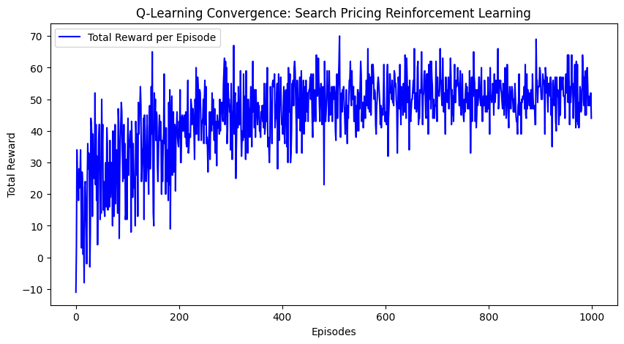

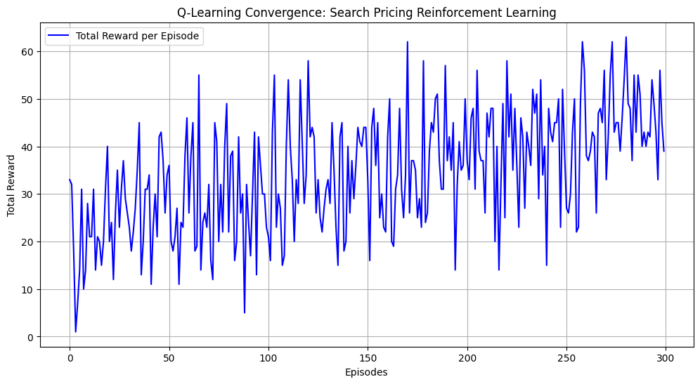

**Insights from the Q-Learning Convergence Graph:**

1. **Convergence Trend**:
   * The total reward increases significantly during the early episodes, showing the agent's learning progress as it explores and exploits better strategies.
   * After around **400 episodes**, the rewards begin to stabilize with less variation, indicating convergence of the Q-learning algorithm toward an optimal policy.
2. **Initial Fluctuations**:
   * In the first 100–200 episodes, rewards are highly variable due to exploration, where the agent tries different actions to learn their outcomes.
3. **Stabilization Phase**:
   * Beyond 400 episodes, the total rewards per episode hover consistently around **50-60**, suggesting that the agent has learned the best pricing strategies in most scenarios.
   * Occasional dips in rewards might be due to randomness in the environment or further fine-tuning of the policy.
4. **Performance**:
   * The consistent reward trend toward the end of training indicates that the reinforcement learning model successfully converged on an effective pricing policy.

**Recommendations:**

1. **Monitor Convergence**:
   * Continue training for a few more episodes to ensure full stability and avoid overfitting to the training environment.
2. **Fine-Tune Parameters**:
   * Evaluate hyperparameters (e.g., learning rate, exploration rate) to confirm they are optimal, as smoother convergence may be possible.
3. **Test in Real Scenarios**:
   * Deploy the learned policy in a simulated or real-world environment to validate its effectiveness and handle potential discrepancies.

# Final Q-Table Heatmap

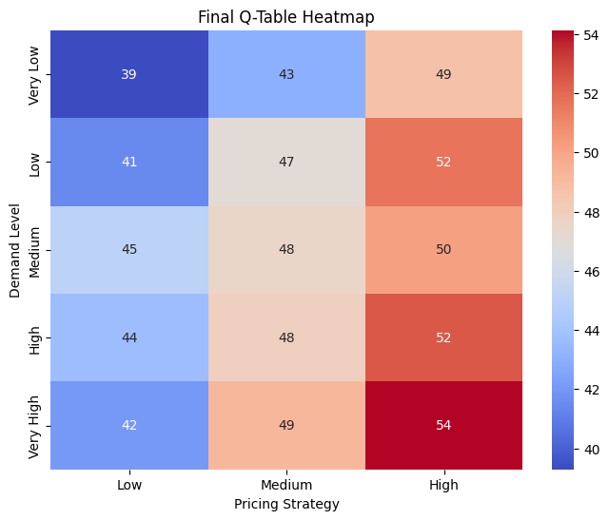

**Insights from the Final Q-Table Heatmap:**

1. **Optimal Pricing Strategies**:
   * **High Pricing Strategy** generally yields the highest rewards, especially when demand is **Very High** (reward = 54) or **High** (reward = 52). This indicates that maximizing profit through higher pricing is beneficial during periods of high demand.
   * For **Medium Demand**, a moderate pricing strategy (Medium or High) is more favorable, with rewards slightly lower than for High Demand.
2. **Demand-Specific Trends**:
   * When demand is **Very Low**:
     + A **High Pricing Strategy** (reward = 49) still performs better than Low or Medium pricing, though the overall rewards are reduced compared to higher demand levels.
   * When demand is **Low** or **Medium**:
     + Rewards progressively increase with pricing strategy, from Low to High.
     + Medium pricing balances reward and affordability.
3. **Performance of Low Pricing**:
   * **Low Pricing Strategy** consistently yields the lowest rewards across all demand levels (e.g., 39 at Very Low Demand), making it less desirable unless there are external constraints like competitive pressure or inventory concerns.
4. **Best-Performing Combinations**:
   * **Very High Demand + High Pricing Strategy**: Yields the highest reward (54), suggesting an aggressive pricing approach maximizes returns when demand is robust.
   * **Low Demand + Medium Pricing Strategy**: Achieves a reasonable balance between rewards (47) and potential demand sensitivity.

**Recommendations:**

1. **Dynamic Pricing Based on Demand**:
   * Adopt a **High Pricing Strategy** during **High** or **Very High Demand** periods to maximize profitability.
   * Use **Medium Pricing** during **Low to Medium Demand** to balance customer retention and profitability.
2. **Avoid Low Pricing**:
   * The Low Pricing Strategy provides minimal rewards across all scenarios, making it a suboptimal choice unless used to attract price-sensitive customers or clear excess inventory.
3. **Fine-Tune for Edge Cases**:
   * For **Very Low Demand**, consider strategies beyond pricing (e.g., discounts or promotions) to improve outcomes, as even high pricing underperforms in this scenario.

**1. K-Means Clustering**

* **Clusters Observed**: Three distinct clusters were formed.
* **Insights**:
  + The clustering indicates clear groupings, suggesting inherent differences in wine compositions.
  + Each cluster likely corresponds to different wine types (e.g., high alcohol, medium phenols, or distinct flavor profiles).
  + K-Means assumes equal-sized clusters, so the groups may overlook irregularities or noise in the data.
  + Suitable for segmentation when a fixed number of groups is expected.

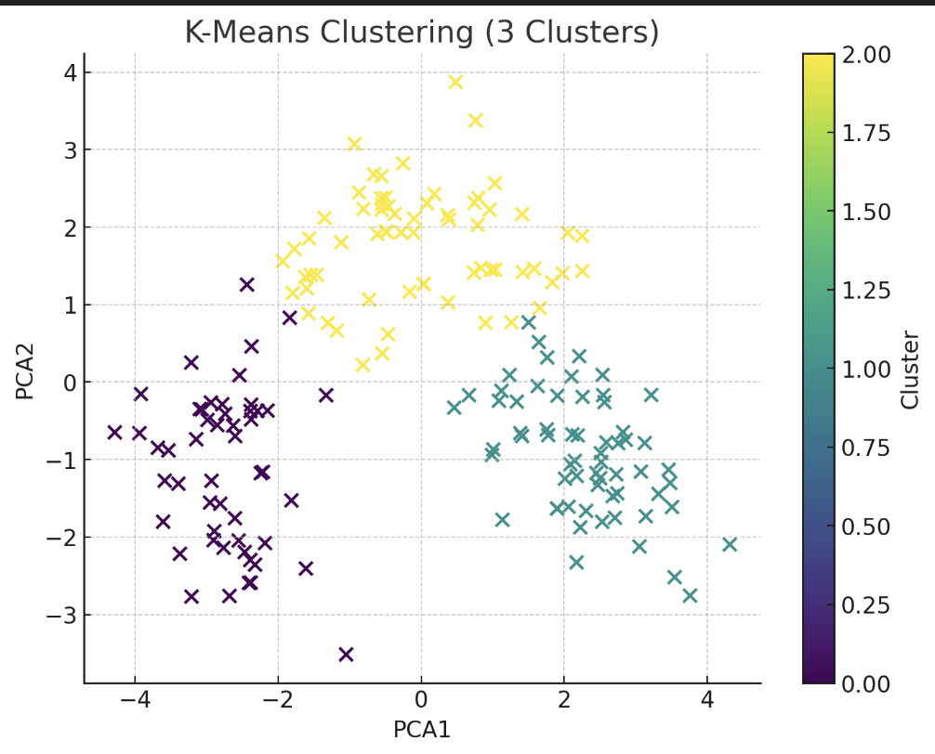

**2. Hierarchical Clustering**

* **Clusters Observed**: Three clusters were identified, as seen from the dendrogram and PCA visualization.
* **Insights**:
  + Hierarchical clustering revealed a structured merging process, offering flexibility to choose an appropriate number of clusters.
  + It captures relationships better than K-Means, especially for clusters with varying sizes or densities.
  + This approach is ideal for smaller datasets where the hierarchy provides meaningful groupings (e.g., gradual differentiation of wine types).

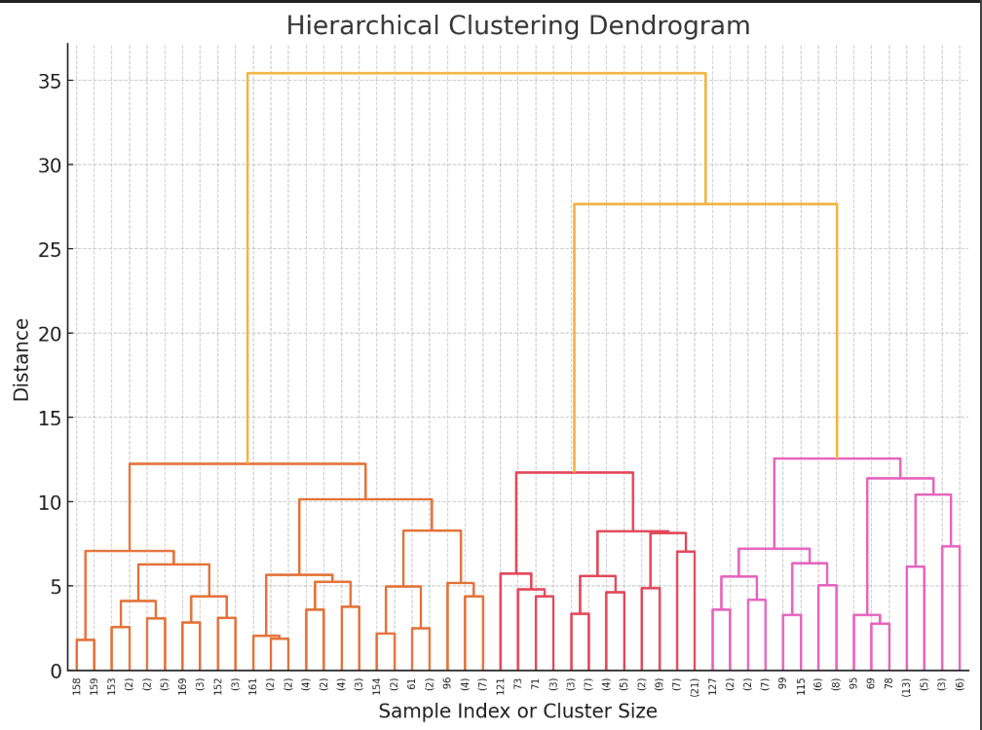

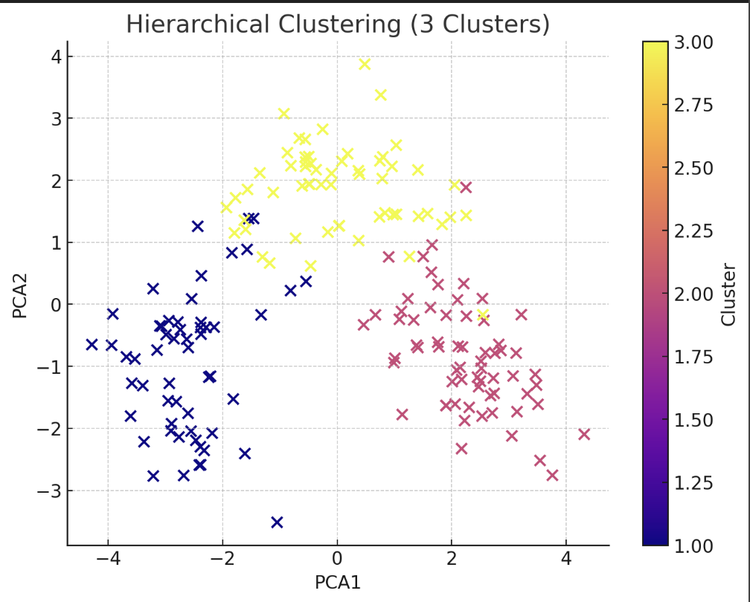

**3. DBSCAN Clustering**

* **Clusters Observed**: The method identified dense regions as clusters and flagged some points as outliers.
* **Insights**:
  + DBSCAN effectively handled data irregularities and identified potential outliers (e.g., wines with atypical compositions that don’t belong to any cluster).
  + This is particularly valuable for datasets with noise or non-spherical cluster shapes.
  + However, DBSCAN's results are highly sensitive to parameter tuning (eps and min_samples).

**Overall Comparison Across Clustering Methods**

* **General Observations**:
  + The dataset contains distinct groupings, likely reflecting variations in key wine attributes like alcohol content, phenols, and flavonoids.
  + Both K-Means and Hierarchical Clustering provided consistent groupings, indicating a stable underlying structure.
  + DBSCAN added value by identifying outliers, which may represent unique or rare wine samples that don’t fit general patterns.
* **Key Attributes Likely Influencing Clusters**:
  + **Alcohol**: Higher alcohol levels may drive specific clusters.
  + **Phenols & Flavanoids**: Variations in these attributes could define quality or flavor differences in wines.
  + **Color Intensity**: This may play a role in separating lighter versus darker wine types.
  + **Proline**: This amino acid, often linked with wine sweetness, might differentiate clusters.

